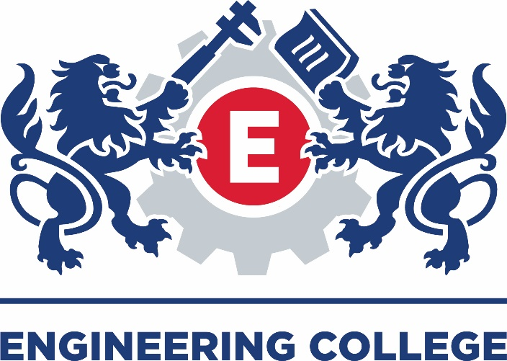

QUALITY MANAGEMENT SYSTEM POLICY

DIVERSITY AND EQUAL OPPORTUNITIES POLICY
The implementation of this particular Policy must always be carried out in conjunction with, and meet the requirements of the GDPR Policy.

Quality Statement
“The Engineering College Quality Management System operates to support and guide staff, learners and employers in effective engagement with the services and products provided by the organisation, seeking to ensure a consistent and continuously improving quality experience to exceed the users expectations”.

Our Vision
“To inspire a new generation of Engineers.”

Our Mission

“Delivering outstanding technical training and assessment, connecting industry with education”

Our Values

“To act professionally with integrity and strive for excellence”

QUALITY CHAMPION – J Armour
Diversity and Equal Opportunities
1.1 Introduction
This policy and plan describes the values and commitments of the Board and staff of the Engineering College. Those same values and commitments are required of all who work with the Engineering College as trainees, sponsoring employers, contractors and visitors.

1.2 Values
The organisation believes that both work and learning require effective co-operation and teamwork, and that teams are strongest where their members have a range of skills, aptitudes, interests and backgrounds. Teams which are diverse are able to cope with the wide variety of challenges and opportunities in modern life and work. Differences may be of gender, ethnicity, ability, age, nationality, first language, religion, belief, sexuality, social background, culture, appearance, experience, or health. Irrespective of such differences, all people are of equal value and are equally deserving of respect and of the opportunity to develop their full potential.
Equality of opportunity does not mean that everybody is the same or should be treated in exactly the same way. It means that everyone should be respected for their own characteristics and abilities and that they should be treated in ways which make the best of those abilities. In practice this means that the organisation will work to ensure that, in its own premises and in those places where it has influence, respect, tolerance, thoughtfulness and goodwill will shape the behaviour of everyone. Their opposites – violence, rudeness, offensive names or ‘jokes’, harassment of individuals or small groups of people, bullying, the display of pornographic or racist material, ignoring or shunning people – are not acceptable and are likely to attract sanctions.
Achieving greater diversity and equality of opportunity is a practical matter, requiring careful thought, determined action and persistence. Success is measurable in the quality of the organisation, as it affects the wellbeing of every member of staff and every learner; in the quality of learning opportunities, both within the college and in the workplace.

1.3 The Law
The laws of the United Kingdom have promoted equality of opportunity for many years. There is legislation forbidding unfair discrimination on grounds of ethnicity, gender, sexuality, age, disability or religion. This legal framework is being constantly refined and updated. The Engineering College will ensure that, the board, staff, employer partners, contractor and throughout learner briefings, a requirement to comply with the relevant laws is made clear.

A common element of the laws is a requirement to avoid the following:
- Direct discrimination – treating one person less favourably than others because of a personal characteristic
- Indirect discrimination – applying a general policy or practice which has the effect of disadvantaging a particular group of people
- Harassment – uninvited behaviour which undermines people’s dignity and wellbeing
- Bullying – a form of physical or verbal harassment which involves an abuse of power or strength or position
- Victimisation – unfair discrimination directed against someone who has tried to assert or protect their rights, for example by making or supporting a complaint.
1.4 Harassment and bullying
This statement is intended to help members of the Engineering College community to understand clearly the kinds of behaviour which might be regarded as harassment or bullying. What is considered unacceptable by society changes over time: so-called ‘political correctness’. What is required is sensitivity to the position and concerns of other people and care to avoid unintended offence. These are reasonable expectations.

1.5 Gender and sexuality

Unacceptable behaviour may be directed towards men and women. It may consist of unwelcome name-calling; ‘jokes’; hostile attitudes towards particular groups of people that override consideration for the individual; suggestive, vulgar or sexually explicit language and pictures; or unwanted physical contact. Where someone makes it clear that they find language or behaviour objectionable, it should stop. Continuation may well be harassment or bullying.
Some examples of behaviour to avoid:
- Sexually suggestive comments and gestures
- Unnecessary physical contact
- Derogatory remarks about people of a particular gender or sexual orientation
- Unwelcome requests for social and sexual relationships
- Display or sharing of pornographic or sexually-revealing pictures
- Indecent exposure or sexual assault; these are likely to be criminal acts.

1.6 Ethnicity
Racial abuse may be directed at men or women and includes name-calling; ‘jokes’; hostile attitudes towards groups of people that override consideration for the individual; language or behaviour which is known to be unacceptable to the culture of a person from a different ethnic background; and criticism of dress or appearance. In the United Kingdom, where British people come from a wide range of different ethnic groups, it is possible for a person from any background to give offence accidentally or through ignorance. When it is made clear that offence has been given the proper response is to stop and apologise.
Some examples of behaviour to avoid:
- Ridicule for physical or cultural difference
- Exclusion from the activities of the rest of the group, in learning or socially
- Unfair allocation of work or responsibility
- Racist comments, graffiti or wearing of insignia
- Unreasonable rejection of traditional dress
- Abuse, threats or attacks; these are likely to be criminal acts.

1.7 Religion
Religious sensibility is becoming a more prominent feature of life than it has been in this largely secular society. This applies to all religions even though it is most often remarked on in relation to Islam. It is not illegal to challenge religious beliefs but it may cause greater offence than was intended.
Some examples of behaviour to avoid:
- Teasing, or criticising unreasonably dress codes which may be important to believers in a particular religion
- Mocking other people’s beliefs, particularly in front of a group or in public
- Acting on an assumption that people of a particular religion all have the same qualities or characteristics.

1.8 Disability
People with a wide range of disabilities are increasingly able to live a full life and work alongside able colleagues. The ability to learn and to enjoy appropriate learning support at Maritime and Engineering College North West is an essential foundation for that widening of opportunities. The help and encouragement of every member of Maritime and Engineering College North West community is an important part of that support.
Some examples of behaviour to avoid:
- Name-calling referring to a disability
- Exclusion from the activities of the rest of the group
- Unthinking assumption about what a person with disabilities can achieve or do
- Giving unwanted and uninvited help.

1.9 Action
Anyone who feels that they are the victim of harassment or bullying can be assured of a sympathetic hearing from the staff of the Engineering College. The simplest and sometimes the best response is to ask the person who has given offence to stop and for a simple apology to end the matter. That can be inappropriate where the offence is serious or repeated, despite clear indications that it is hurtful or offensive. It can also be impossible; where information technology has been used to harass or bully, for example. However the problem is to be tackled, act promptly, without waiting for it to become intolerable or to threaten wellbeing or health.

In the first instance:
- Ask the person involved to stop being offensive and for a simple apology to close the matter,
or
- Approach a member of staff of the College and ask that they approach the offender on the victim’s behalf
or
- Use the formal Complaints procedure, referring to the Engineering College’s Diversity and Equal Opportunities policy and Safeguarding policy.

1.10 Who is responsible?
Everyone who is part of, or associated with, the Engineering College community is personally responsible for actively promoting the values described in this policy.
Leadership in diversity and equal opportunity issues is carried out by the following people:
Board: (Nominated Board member)
Management: (Nominated Manager and representative committee including learner representation)
The Board of the Engineering College:
- Sets and monitors diversity and equality targets annually
- Approves and monitors the annual development plan
- Monitors improvements in diversity and equality over time
- Takes responsibility for safeguarding young people and vulnerable people
- Reflects on its own performance in diversity and equality matters.
Managers also monitor the implementation of this policy regularly.

The following are some examples of data which are monitored:
- Applications for staff and learner positions from people of different ethnicity/gender in comparison with their representation in the local community
- Successful selection rates of different groups in comparison with applications
- Successful achievement rates of qualifications among different groups of learners in comparison with enrolments

1.11 Positive action

Many occupations are mainly associated with a particular gender or ethnic group. Whilst a predominance of men, for example, may have been justified by a need for physical strength at one time, in the great majority of jobs this is no longer the case but the stereotype may live on. Industries are therefore denied access to the range of talent they need for reasons which make no sense. Where the organisation finds issues of this kind we will work actively to overcome them for the benefit of both employers and learners.

1.12 Linked policies and procedures

This policy statement is intended to help guide everyone in the Engineering College community towards behaviours and attitudes which reflect the best aspects of our society. Nevertheless, where people transgress, sanctions are laid down in a number of associated statements.

- Discipline
- Safeguarding
- Learner selection
- Learner Handbook
- Use of information technology
- Complaints (of misconduct)
- Appeals (against learning outcomes)
- Contractor service-level agreement

